**PATANJALI PRODUCTS CANADA INC**

**Testing Document**

1. **Menu Bar**

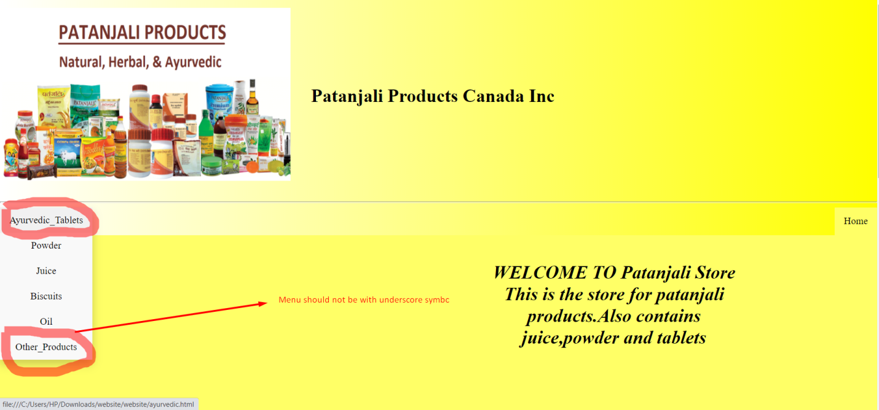

1. **Space before login form**

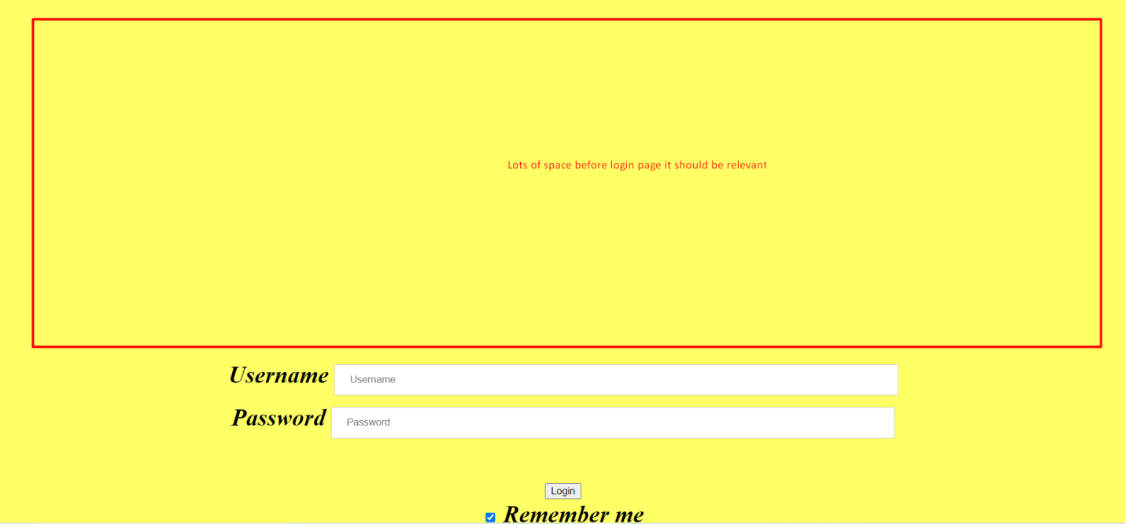

1. **Login and remember me**

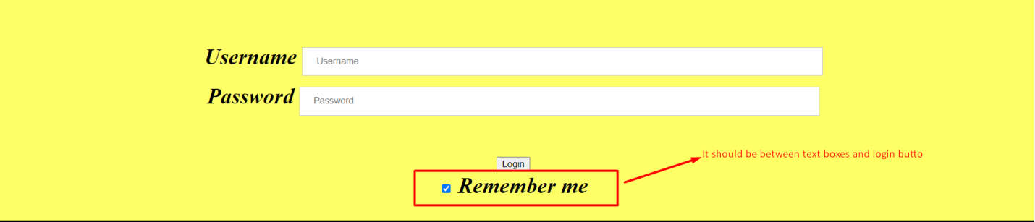

1. **Overlap**

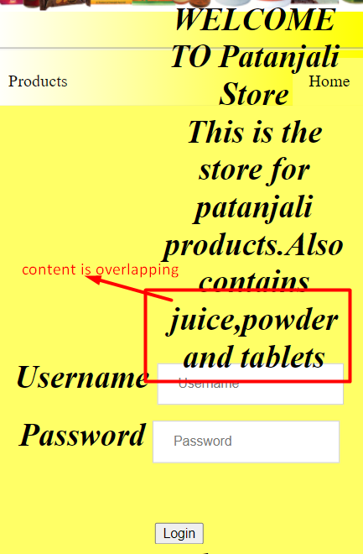

1. **About Us page space**



1. **Ayurvedic page**

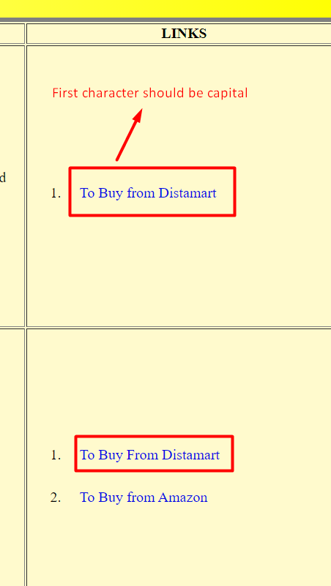

1. **Color**

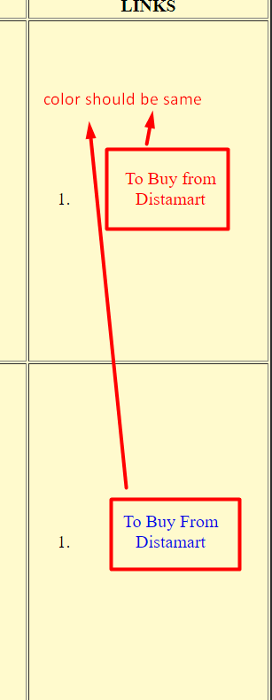

1. **Left and right side margin**

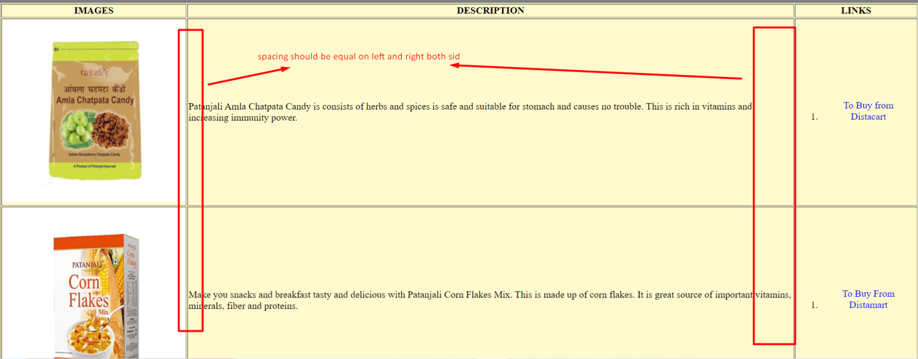

1. **Responsive**

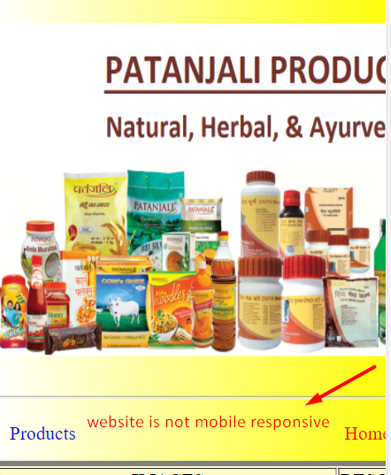

1. **Menu bar**

